Letter Center  Name: ___________________________  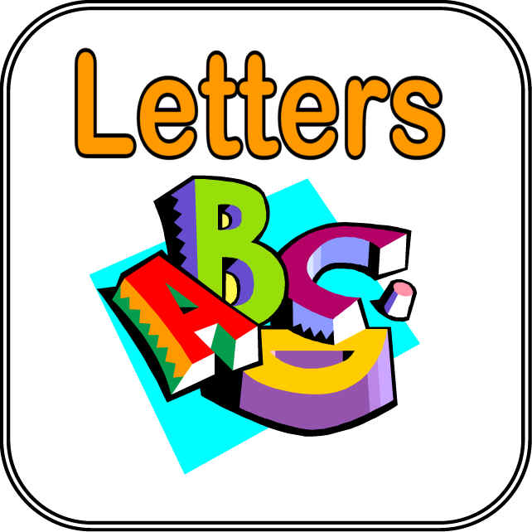  TLW recognize letters and relate letters to sounds.  TLW manipulate letters to make words. | Letter Center  Name: ___________________________  TLW recognize letters and relate letters to sounds.  TLW manipulate letters to make words.

